## East West University

**Department of Computer Science and Engineering**

## A/2, Jahurul Islam Avenue, Jahurul Islam City, Aftabnagar, Dhaka

**Course Code:**

CSE405 (Networking Lab)

**Course Instructor:**

Rabea Khatun, Lecturer, CSE

Title: Configuration of SMTP Server

## Objective(s)

* To build and design a network using Cisco Packet Tracer
* To learn about step-by-step configuration of SMTP Server using Cisco Packet Tracer
* To learn how to transfer mail from one client to another client.

## Problem analysis

The Simple Mail Transfer Protocol (SMTP) is an internet standard communication protocol for electronic mail transmission. Mail servers and other message transfer agents use SMTP to send and receive mail messages. Without an SMTP server, your email wouldn’t make it to its destination. Additionally, the SMTP server verifies that the outgoing email is from an active account, acting as the first safeguard in protecting your inbox from illegitimate email. It also will send the email back to the sender if it can’t be delivered. This informs the sender that they have the wrong email address or that their email is being blocked by the receiving server. Packet Tracer provides Email Server Service to allow composing, sending, and receiving of email. To begin with, SMTP (Simple Mail Transfer Protocol) and POP3 (Post Office Protocol 3) services should be enabled to ON first. SMTP is a protocol for sending an email, while POP3 is the 3rd version protocol for holding and receiving an email.

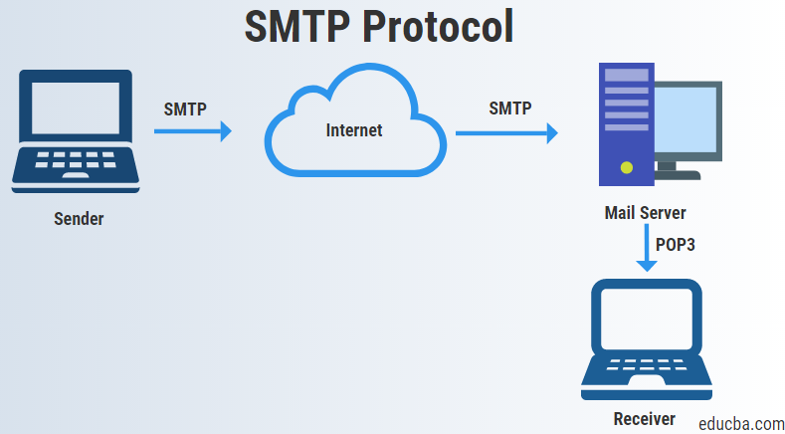

Figure 1: Mail Transfer

## Procedure

1. Create a network topology by setting up all the necessary devices in Cisco Packet Tracer.
2. Configure static **IP addresses** on the PC, Laptop, Mail server, DNS Server, and other devices.
3. For SMTP Server Configuration, click on the Server and go to the EMAIL option then at the right side click On to enable the SMTP and POP3. Then, set the domain name and create a user with password.
4. Notice that a domain name is set for the mail server. For that reason, a DNS server is required for resolving this domain name to IP address. For DNS server configuration, click on the Server. Then select the DNS option and at the right side turn On the DNS. After that, set the domain name and IP address. Finally, add them to the server.
5. Now, configure the mail client on the PCs. Click PC and click the Desktop tab > Email. Enter your Name, Email address, incoming Mail Server, outgoing Mail Server, user Name, and Password. Finally, save the information. After completing the process, the Mail Browser window displays. Now, the client can compose, reply, delete, and receive email.

## Configuration

1. Build the network topology

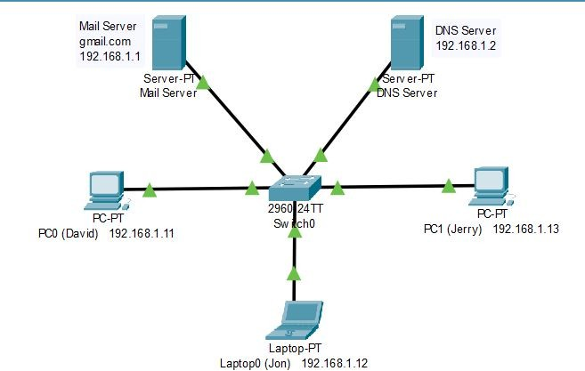

Figure 2: Build the network

1. Configure static **IP addresses** on the PC, Laptop, Mail server, and DNS server (Figure 3).

a) Click the device and go to the **Desktop tab > IP Configuration**.

**For PC0 (David):** Set 192.168.1.11 as IP address and 255.255.255.0 as Subnet Mask. **For Laptop0 (Jon):** Set 192.168.1.12 as IP address and 255.255.255.0 as Subnet Mask. **For PC1 (Jerry):** Set 192.168.1.13 as IP address and 255.255.255.0 as Subnet Mask.

**For Mail Server (gmail.com):** Set 192.168.1.1 as IP address and 255.255.255.0 as Subnet Mask.

**For DNS Server:** Set 192.168.1.2 as IP address and 255.255.255.0 as Subnet Mask.

1. Click on the **Server** and then clicking on the **“Services”** option to mail server configuration (Figure 4(a)).
   1. Click on the **EMAIL** option then at the right side click **On** to enable the SMTP and POP3.
   2. Set the domain name to **gmail.com** and click **Set**.
   3. Create **users** with **password**. Click **“+”** to add the user.
2. For **DNS** server configuration, click on the **Server** and then select the **“Services”** tap.
   1. Click on the **DNS** option then at the right side turn **On** the DNS.
   2. Set **name** to **gmail.com** and **address** to **192.168.1.1** (IP address of mail server). Finally, **add**

them to the server (Figure 4(b)).

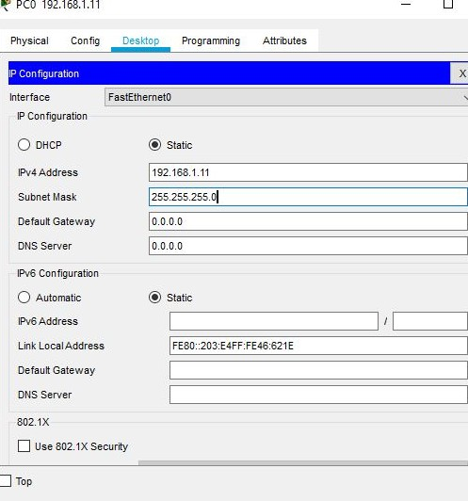 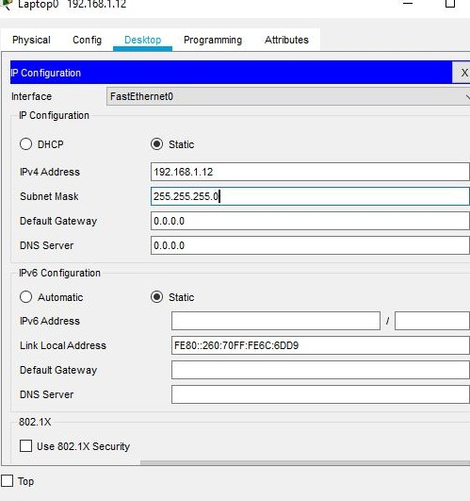

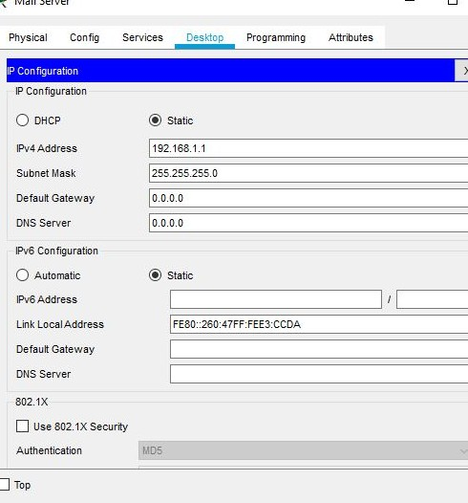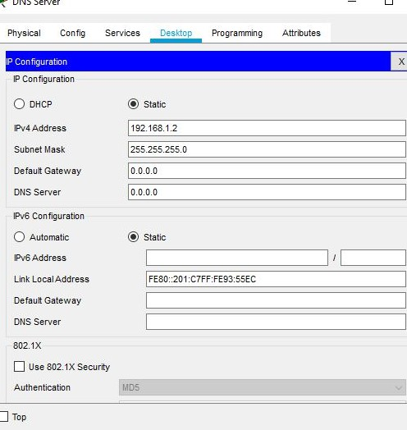(a) IP Configuration of David’s PC (b) IP configuration of Jon’s Laptop

* 1. IP Configuration of Mail Server (d) IP configuration of DNS Server

Figure 3: IP Configuration of End Devices

## Input/Output

### Part 1: Send an Email from David to Jon

1. Configure **PC0 (David)** to use the Email service of the Mail server
   1. Click **PC0 (David)** and click the **Desktop tab > Email**.
   2. Enter the following values into their respective fields:
      1. Your Name: **David**
      2. Email Address: [**david@gmail.com**](mailto:david@gmail.com)
      3. Incoming Mail Server: **192.168.1.1**
      4. Outgoing Mail Server: **192.168.1.1**
      5. User Name: **david**
      6. Password: **12**

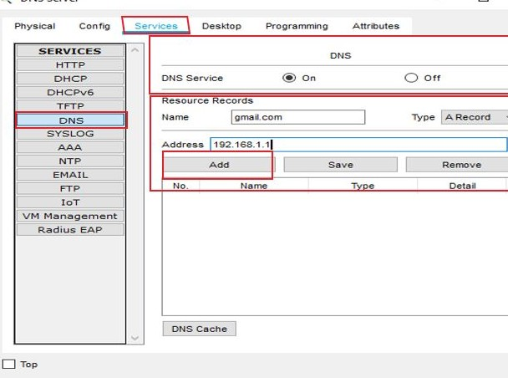

* + - 1. 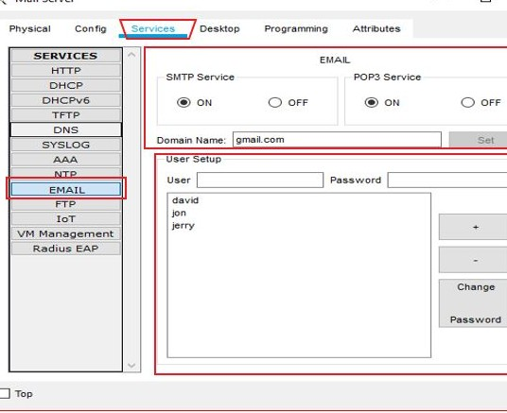Mail Server
      2. DNS Server

Figure 4: Configuration of Mail Server and DNS Server

* 1. Click **Save**.

1. From David Mail Browser window, click **Compose** for sending an email.
   1. Enter the following values into their respective fields:
      1. To: [**jon@gmail.com**](mailto:jon@gmail.com)
      2. Subject: **Greeting**
      3. Email Body: **Personalize the email**.
   2. Click **Send**.

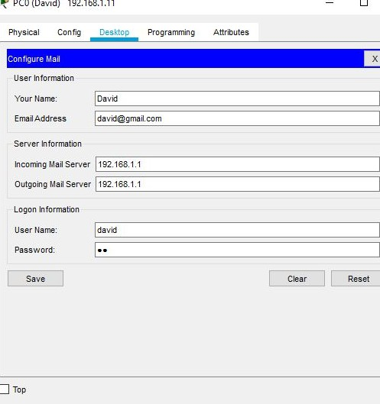

Figure 5: Sending an Email from David to Jon, Step 1: Configuration of PC0 (David) to use the Email service of the Mail server

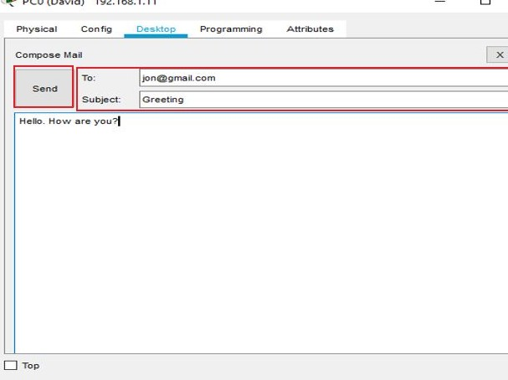

1. 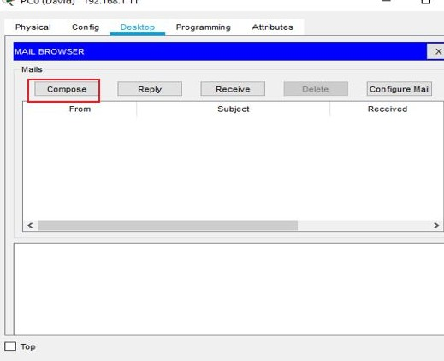Step 2: Compose for sending an email
2. Step 3: Sending an email

Figure 6: Sending an Email from David to Jon (a) Step 2 (b) Step 3

### Part 2: Check whether Jon received the email or not

1. Configure **Laptop0 (David)** to check the received email.
   1. Click **Laptop0 (Jon)**. If the Mail Browser window is closed, click **Desktop tab > Email**.
   2. Enter the following values into their respective fields:
      1. Your Name: **Jon**
      2. Email Address: [**jon@gmail.com**](mailto:jon@gmail.com)
      3. Incoming Mail Server: **192.168.1.1**
      4. Outgoing Mail Server: **192.168.1.1**
      5. User Name: **jon**
      6. Password: **23**
   3. Click **Save**.
2. From Jon Mail Browser window, click **Receive**. An email from David displays.

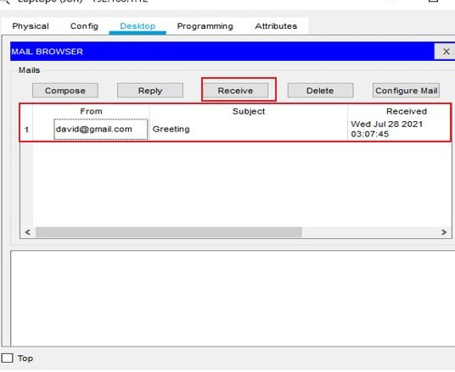

(b) Receiving the email

* 1. 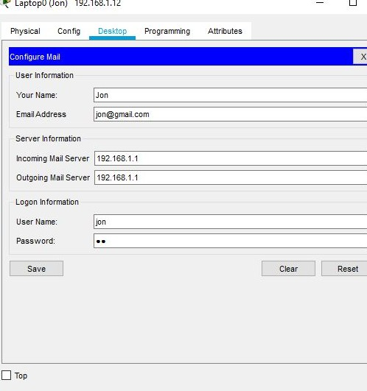Configuration of Laptop0 (David) to check the received email.

Figure 7: Checking whether Jon received the email or not

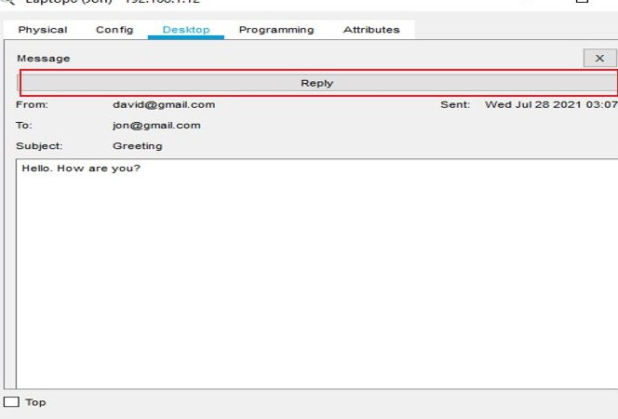 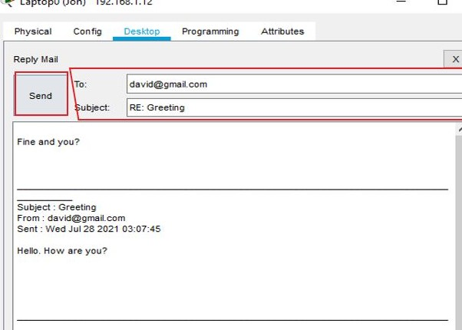

(a) Step 1 (b) Step 2

Figure 8: Replying to the Email

### Part 3: For replying to the Email

1. If Jon wants to reply to the email to David. Double-click the email.
2. Click **Reply**, personalize a response and click **Send**.